**To Find if a number is positive or negative**

Program:

%{

#include<stdio.h>

#include<stdlib.h>

%}

digit [0-9]

%%

[0] {printf("You have entered zero");}

\+?{digit}+ {printf("You have entered a positive number");}

-{digit}+ {printf("You have entered a negative number");}

%%

int main()

{

printf("Enter a number\n");

yylex();

}

Output:

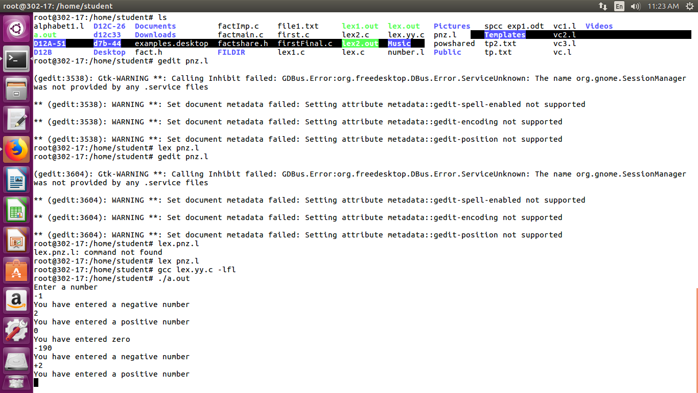

**Counting number of Vowels and Consonants**

Program:

%{

#include<stdio.h>

#include<stdlib.h>

int vowel = 0, con = 0;

%}

%%

[aeiouAEIOU] vowel++;

[a-zA-Z] con++;

%%

int main()

{

printf("Enter a string\n");

yylex();

printf("No of vowels is %d and consonants is %d\n",vowel,con);

}

Output:

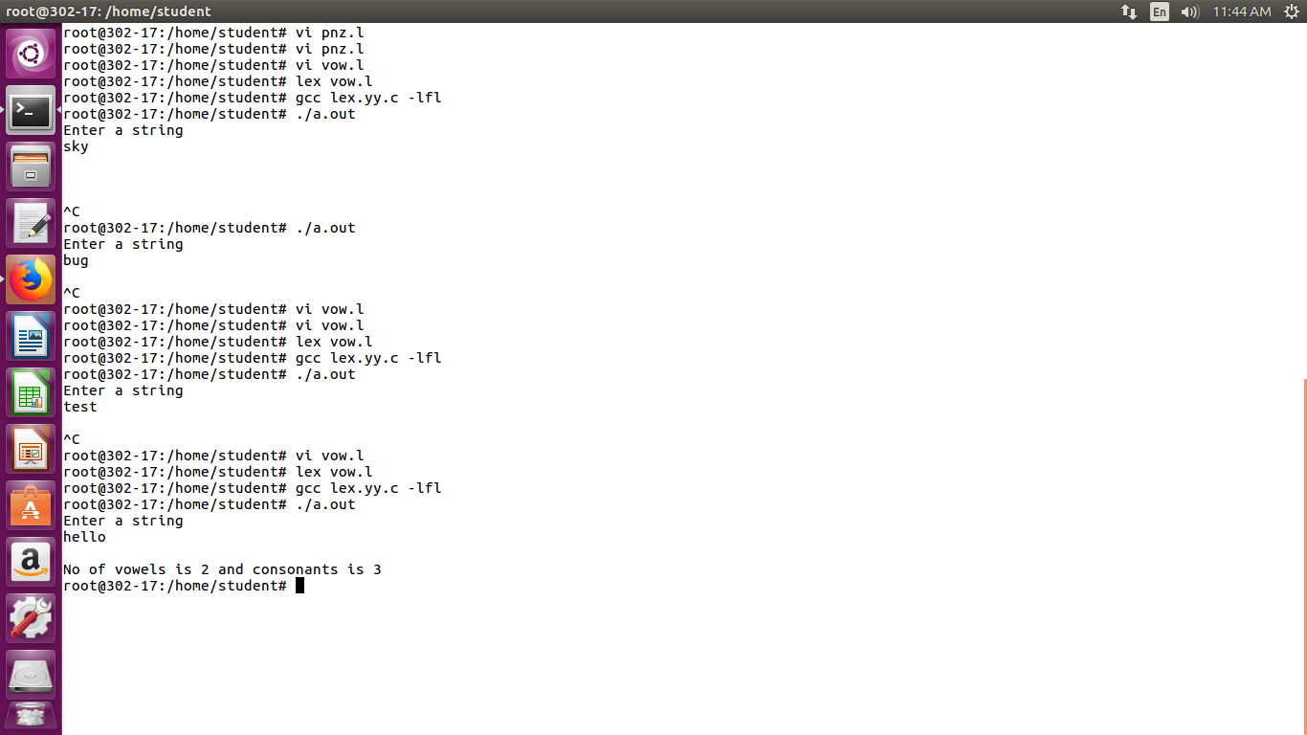

**Counting number of printf and scanf in a string**

Program:

%{

#include<stdio.h>

#include<stdlib.h>

int p = 0, s = 0;

%}

%%

(printf) p++;

(scanf) s++;

%%

int main()

{

printf("Enter a string\n");

yylex();

printf("printf count = %d\nscanf count = %d",p,s);

}

Output:

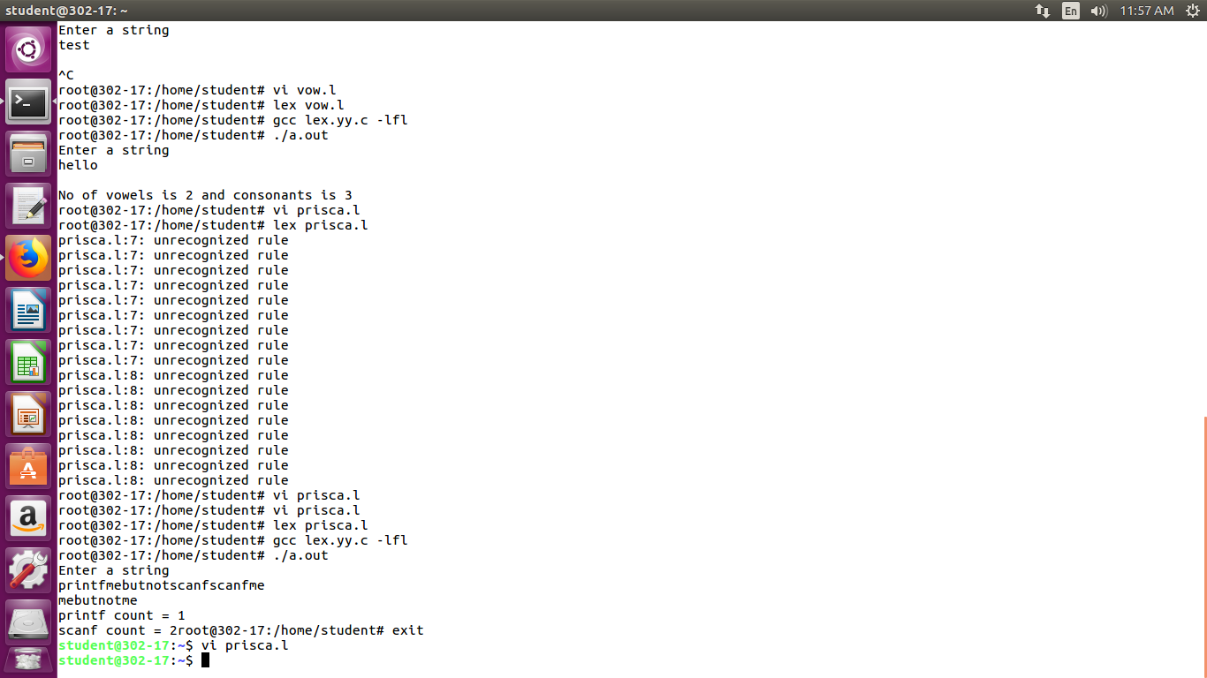

**Count number of adverbs, adjectives, and verbs in grammar**

Program:

%{

#include<stdio.h>

#include<stdlib.h>

int adv = 0, adj = 0, verb = 0;

%}

%%

(easily) adv++;

(lazy) adj++;

(runs) verb++;

%%

int main()

{

printf("Enter a string\n");

yylex();

printf("adjective count = %d\nadverb count = %d\nverb count = %d",adj,adv,verb);

}

Output:

